DISABILITY PROCESS
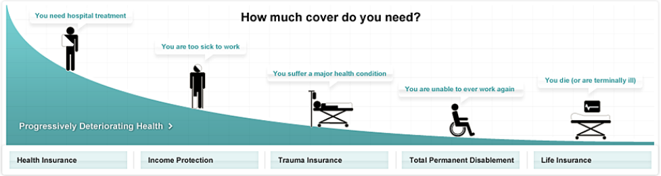
Understanding the 'Disablement Process'

In real life, it's rare for people to suddenly pass away (for example in a car crash, or of an undiagnosed health problem).

For most people a period of gradually worsening health, known as the "Disablement Process", comes first.

How long this process will take is unknown - it could be relatively short or take many years.

But what is certain is that each stage brings with it serious financial challenges, such as paying bills, mortgage, lifestyle cost, medical bills to name a few.

How insurance works during this process

At each stage of the Disablement Process there is a type of insurance designed to provide financial assistance.

For example

Health insurance helps with medical costs when hospital treatment is needed - while life insurance pays a lump sum on death leaving money for your family.

Disability Income Benefits such as MRI, Income Protection, Household Expenses allow you to protect clients greatest asset - their ability to earn an income. It provides for a monthly payment to be made to an individual who is unable to work due to sickness or injury. It is essential for anyone with a partner or a family dependent on the insured's income for the maintenance of their lifestyle.

Do ensure your suggested levels of cover is right for you and your family.

The trick with a good insurance package is to make sure you have some cover for each stage, while at the same timekeeping within your budget.

